**DLD Lab 09 – Home Assignment**

**Task 02(a):**

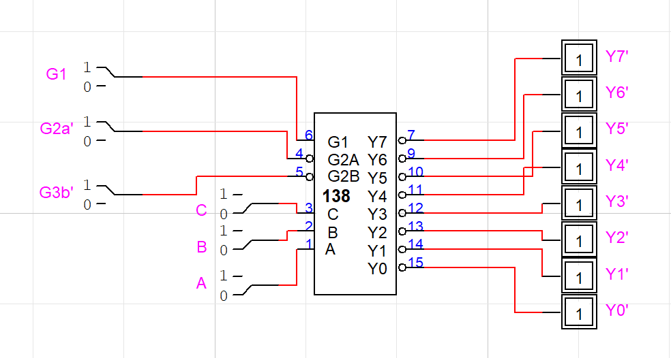

**Task 03(a):**

